COSEE Hands-On Activities
USA Science & Engineering Festival
Grouping: Chemical Oceanography

Lesson/Activity: Parts Per Thousand/Concentration
http://www.ucar.edu/learn/1_4_2_14s.htm

It doesn't necessarily take a large quantity of a substance to have a significant effect on water quality. Contaminants in water are commonly measured in parts per million (ppm) or parts per billion (ppb). In this activity, you will explore how many dilutions of a pure substance (food coloring) are needed to produce a 1 part per million concentration.

Materials
- Ice cube tray
- Permanent marker
- Pipettes
- Food coloring
- Water

Procedure
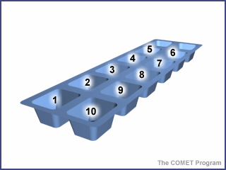
- Use a marker to label ice cube tray "cells" 1 to 10.
- Fill your plastic cup about half full of water for eye dropper (or pipette) cleaning.
- In cell #1, place 10 drops of food coloring. This represents a pure substance, or a concentration of 1 million ppm.
- Take one drop of the food coloring from cell #1 and place it in cell #2.
- Rinse the dropper in one of the plastic cups to remove all traces of food coloring.
- Add 9 drops of clean water to cell #2 and stir the mixture. The mixture is now diluted to 1/10th of the original concentration, or 100,000 parts food coloring per million parts of solution.
- Take one drop from cell #2 and place it in cell #3.
- Rinse the dropper again.
- Add 9 drops of clean water to cell #3 and stir the mixture. How concentrated is the food coloring now, in ppm?
- Repeat the above procedure for cells #4 to #10 (remember to clean the dropper between uses). After each dilution, record the new concentration in the cell in ppm.

Observations and Questions
- In which cell is the color most intense? And why?
- In which cell is the color least intense? And why?
- In which cell did the solution become colorless? Is there any food coloring in this cell? How do you know?

Cell | 1 | 2 | 3 | 4 | 5 | 6 | 7 | 8 | 9 | 10
Do you see color?
ppm | 1,000,000 | 100,000

